INCLINED PLANES

An incline plane makes it easier to move an object up to a height rather than lifting it.

The force required is smaller but a larger distance is involved.

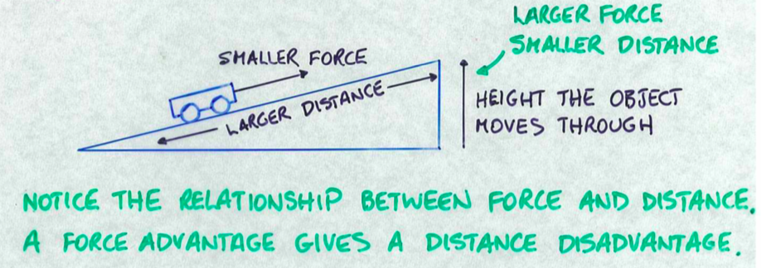

Examples
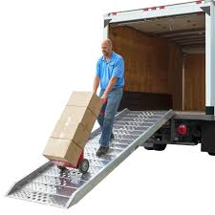
1. Ramp

As shown above, a smaller force is required to move a heavy object to a height.

i.e. The force is less than the weight of the object.

2. Axe and wedge

Simple wedge shape that has 2 incline planes on each side.
Large splitting force for a small effort force.
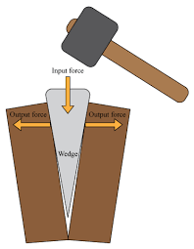
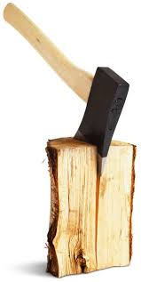

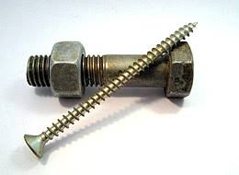
3. Screw

The thread acts as a continuous incline plane.

A small turning force on the head of the screw exerts a large force to hold things together.

4. Nut and bolt

Same as a screw.

5. Car jack or bench vice

Screw thread makes it easy to exert a large lifting or gripping force.
